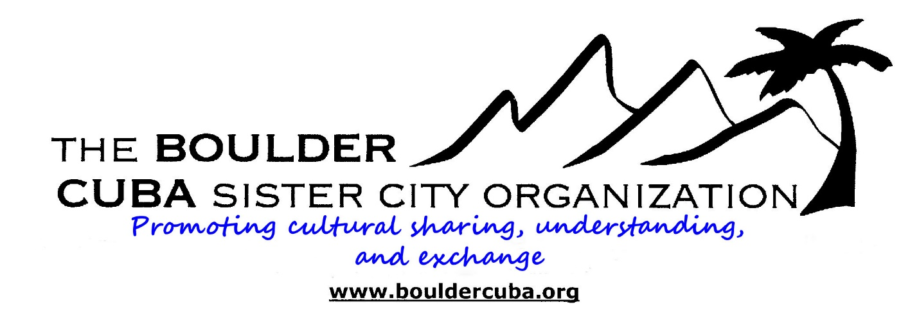presents:

**Havana Art Biennial**

**May 22-30 2015**

The Cuban art scene is hot, and from May 22-June 22, 2015, the legendary city of Havana celebrates art in all of its forms. The Havana Art Biennial is a multi-venue arts festival featuring creative, innovative, provocative and sometimes controversial art by the best Cuban, Latin American and other third world artists. Set in museums, plazas, studios and public spaces in an historic city that is a work of art in itself, the Biennial attracts art lovers from around the world. This year the Boulder-Cuba Sister City Organization is offering a small group of people the opportunity to immerse themselves in the art, architecture, music and dance of Cuba during the opening week of the 2015 Havana Art Biennial.

**Trip limited to 10 participants**

**Proposed itinerary**

(Subject to change depending on Biennial art, dance, and music events and performances, as well as the interests of the trip participants.)

**Friday, May 22**: 6:00 pm meeting at our hotel in Tampa, Florida, to receive documents and last minute details. (Transportation to Tampa and Tampa hotel not included in trip price. Hotel to be named later.)

**Saturday May 23**: Fly to the fabled city of Havana from Tampa. Transfer to our hotel in Habana Vieja (Old Havana), a UNESCO World Heritage Site, and the best preserved example of Spanish Colonial architecture in the Americas.

Welcome dinner at a favorite private restaurant in Old Havana.

Evening free to begin to explore Old Havana or to attend a Biennial activity.

**Sunday May 24**: AM: Guided tour of the Cuban Collection at Havana’s Museum of Fine Arts.

3:00 PM: Optional taxi to Callejon de Hamel to view the Afro Cuban inspired murals and to experience authentic Cuban rumba.

Evening: Optional Dinner at el Meson de la Flota for an exciting Flamenco music and dance performance.

**Monday May 25**: AM Guided tour of the Museum of the Revolution to learn more about the important events in the history of contemporary Cuba.

Afternoon: Walking tour orientation to Old Havana with visits to artists’ studios along the way.

Evening: Taxi to Cabaña fortress across Havana Bay to view art and attend the historic cannon ceremony. Dinner on your own at La Cabaña.

**Tuesday May 26**: AM: Architectural tour of the city to understand its urban development and its eclectic architectural styles, including colonial, art deco, art nouveau, and modernism.

Afternoon: optional salsa dance lesson at one of Havana’s best studios, and free time to enjoy Biennial activities.

Evening free to discover another of Havana’s fine private restaurants, and attend a dance performance or music concert or jazz club.

**Wednesday May 27**: Morning: Discover Hemingway’s Cuba. We will take 1950s classic cars 8 miles outside of the city to the Finca Vigia, Hemingway’s home between travels for 20 years. The home and its contents remain much the same as Hemingway left them in 1960. We will also visit the small seaside village, Cojímar, which Hemingway immortalized in *The Old Man and the Sea.* Back in Havana we might visit two of his favorite bars, La Floridita where he had his daiquiris, or El Bodeguita del Medio where the mojito was created.

Afternoon and evening: Free time to participate in Biennial activities, visit the Crafts market, or take another dance lesson.

Optional cocktails or dinner on the rooftop terrace of the Ambos Mundos hotel, where Hemingway first stayed in Havana and where his room is now a museum.

**Thursday May 28**:

Spend the morning in the section of Havana called Vedado, an elegant neighborhood started in the late 19th century by the wealthy class who wanted to leave crowded Old Havana for large mansions with spacious grounds and greenery. Vedado is home to several museums and galleries.

Late afternoon suggestion: Enjoy the peaceful gardens of the Hotel Nacional overlooking the Straits of Florida and the Malecón, Havana’s sea front drive.

**Friday, May 29**: On our last day in Havana we will try to fit in whatever activities you are anxious to do.

Farewell dinner at a favorite restaurant.

**Saturday, May 30** Transfer to airport for flight to Tampa

**PROGRAM COST: The preliminary price estimate is $2850 per person, double occupancy. ($200 single occupancy supplement)**

**Included: Round-trip airfare Tampa-Havana-Tampa**

**Cuban visa**

**Cuban health and evacuation insurance**

**7 nights in a hotel in Old Havana**

**Welcome and farewell dinners**

**All breakfasts**

**Experienced BOCUSCO bilingual tour leader**

**Guided tours and talks by experts in their fields**

**Access pass to Biennial activities**

**Museum admissions**

**Ground transportation for scheduled activities**

**Not included: Transportation to and from Tampa; hotel in Tampa**

**Gratuities for hotel maids, porters, restaurant staff**

**Most lunches and dinners**

**Personal purchases. REMEMBER: Under the new US Cuba travel guidelines, travelers may bring back $400 worth of items purchased in Cuba, including $100 worth of rum and cigars.**

**Your BOCUSCO trip leader**: Kate Hennessey, BOCUSCO VP, has been traveling to Cuba as a student, teacher, book editor, and tour leader since 1999. Kate holds MA degrees from the University of Wisconsin-Madison (Spanish) and the University of Iowa (French). **For questions about this trip please call her at 303 499 1061.**



*Promoting cultural sharing, understanding and exchange*

[**www.bouldercuba.org**](http://www.bouldercuba.org)

**Contact us at** [**bocusco@yahoo.com**](mailto:bocusco@yahoo.com)

**BOCUSCO Havana Art Biennial 2015**

**May 22-30, 2015**

The Boulder-Cuba Sister City Organization will sponsor an educational trip to the Havana Art Biennial in May, 2015. Delegation participants must be members of or join the Boulder-Cuba Sister City Organization and be approved for travel by the Board of Directors. This delegation will be limited to 10 participants.

If you are interested in being part of this unique cultural opportunity, please complete the following application and return with a $200 deposit (non- refundable if approved by the Board) by February 22 to:

Kate Hennessey

2835 Lagrange Circle

Boulder, CO 80305

Name as it appears on your passport: ­­­­­­_________________________________

Mother’s maiden name____________________________________________

Passport number_______________________ Expiration date______________

(passport must be valid for 6 months after departure from Cuba) **PLEASE ATTACH TWO COLOR PHOTO COPIES OF THE INFORMATION PAGE OF YOUR PASSPORT**.

Address: _______________________________________

Email address: ___________________ Phone: ___________________

Date and place of birth __________________________________

Emergency contact in the US ­­­­­­­­_________________________________________

Occupation (if retired, from what field) ________________________________

Do you want a single room? (single supplement of $200 applies) ___________________

If no, do you have a roommate? Name_________________________________

1. What is your interest in Cuba?
2. What would you like to see, do, or learn on this trip?

3. What interests and issues would you like to discuss with the Cubans we meet?

4. How do you envision contributing to the success of the trip? What talents and skills will you be able to share?

1. Tell us about your involvement with humanitarian or non-profit organizations.
2. How would you like to contribute to the Sister City Organization upon your return?
3. Do you speak Spanish? If so, at what level?
4. Do you have any physical or dietary restrictions? Please explain.

(Participants must be able to walk unassisted and carry their own bags. Havana has many uneven cobblestone streets.)

**Anticipated Travel Dates and Costs**

**Travel dates**: The trip is scheduled to begin Friday May 22, 2015, at 6 pm in Tampa where the delegation will meet for a brief orientation meeting. We will fly to Havana from Tampa Saturday, May 23, returning May 30.

**These dates are subject to change depending on Tampa-Cuba charter airline schedules that are not yet set for May. Please don’t make your Boulder-Tampa reservations yet.**

**Estimated travel costs:** The Sister City Organization will arrange flights to/from Tampa and Cuba, transportation in Cuba, an experienced bilingual sister city tour leader and a bilingual Cuban guides within Cuba, 7 nights in three or four star hotels in Havana (double occupancy, includes breakfast), Cuban health insurance, and some other related travel costs (Cuban visa, other paperwork.) Travelers will be responsible for travel to and from Tampa, hotel in Tampa, most meals (other than breakfast), drinks, optional activities, and personal expenses.

The estimated cost is $2850 per person, double occupancy. ($200 single supplement.)

A deposit of $200 is required by February 22, and the final payment by Apri